 | Grocery Shopping and Delivery Management Technical Design Document
 | Prepared By / Last Updated By | Reviewed By | Approved By
Name | Mayank Mohnani / Sakshi Gupta | Ashu Jauhari
Role | Trainee | Trainer
Signature | Mayank Mohnani / Sakshi Gupta | Ashu Jauhari
Date | 12-Mar-20 | 12-Mar-20

Table of Contents

1.0 Introduction 3
1.1 Purpose of this document 3
1.2 Project overview 3
2.0 Solution Summary 3
2.1 Scope 3
2.2 Assumptions 3
2.3 Dependencies 3
2.4 Risks 3
3.0 Schematic Diagram 4
4.0 System Design 4
4.1 Proposed design 4
4.2 Component inventory 4
5.0 Database Design 5
5.1 Data Model 5
5.2 Tables Structure 6
6.0 Appendices 8
6.1 Glossary 8
6.2 Other 9
7.0 Terms & Conditions 9
8.0 Change Log 9

Introduction

Purpose of this document
The purpose of this document is to document the technical design, component details and Database design. This will also capture the scope, assumptions, risk, dependencies of this project.

Project overview
Grocery Shopping and Delivery Management System is capable of managing each and every Grocery items over the web application. Grocery Shopping and Delivery Management System helps us in managing in an extremely efficient way. User can order items online and Admin can maintain the items details of orders and can assign the delivery agent. And after successful delivery of order, user can be able to give the feedback of the products

Scope
The main aim for developing this module is to provide all the functionality related to convenient Shopping. Admin can track all the information and details of the product and users. This is a role based module where admin can perform each and every operations on data but the customer will be able to view only his/her data, so access level restrictions has also been implemented on the project.

Assumptions
- Admin is responsible to handle the data of grocery items.
- The review that is triggered is the average of all the user’s review.

Dependencies
Not Applicable.

Risks
Not Applicable.

Schematic Diagram
A schematic, or schematic diagram, is a representation of the elements of a system using abstract, graphic symbols rather than realistic pictures. It gives an overview of overall system
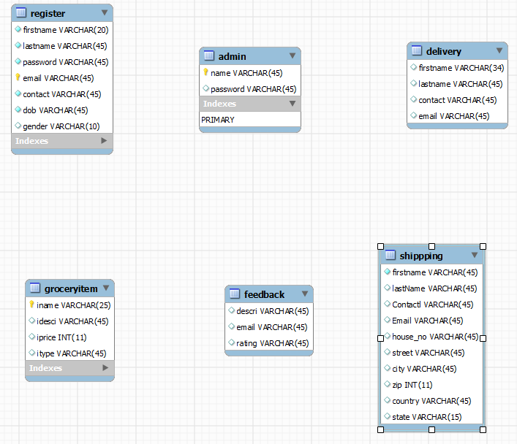

System Design

Proposed design
We are proposing an automated system using which the Admin can store details about the items in to the application. Item details can be added up to date and modify if required. User can add their personal details for order delivery and Admin can assign the agent for delivery. And after successful delivery of order, user can be able to give the feedback of the products.
- Menu can be updated as per the need.
- Auto billing is enabled.
- Easy to reset forgotten password.
- Feedback is taken automatically.
- Inventory is controlled by a click.
- Order history and reviews can be seen.

Component inventory
Not Applicable.

Database Design

Data Model

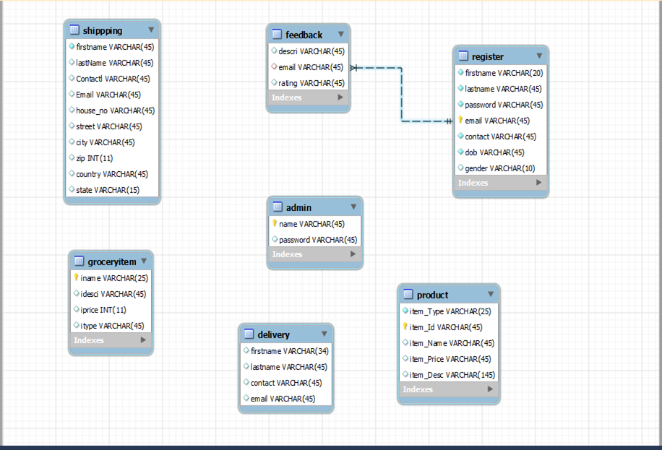

Tables Structure
There are six tables in our application that are:
- Admin 2. Register 3. Groceryitems 4. Shipping 5. Delivery 6. Feedback
1. Admin_details
Column Name | Data Type | Length | Nulls
user_id | VARCHAR | 45 | Not Null
password | VARCHAR | 45 | Not Null

- Register
Column Name | Data Type | Length | Nulls
firstName | VARCHAR | 45 | Not Null
lastName | VARCHAR | 45 | Not Null
password | VARCHAR | 45 | Not Null
email | VARCHAR | 45 | Not Null
contact | VARCHAR | 45 | Not Null
dob | VARCHAR | 10 | Not Null
gender | VARCHAR | 45 | Not Null

- Groceryitems
Column Name | Data Type | Length | Nulls
iname | VARCHAR | 45 | Not Null
idesc | VARCHAR | 45 | Not Null
iprice | INT | 11 | Not Null
itype | VARCHAR | 45 | Not Null

4. Shipping
Column Name | Data Type | Length | Nulls
firstName | VARCHAR | 45 | Not Null
lastName | VARCHAR | 45 | Not Null
contact | VARCHAR | 45 | Not Null
email | VARCHAR | 45 | Not Null
house_no | VARCHAR | 45 | Not Null
street | VARCHAR | 45 | Not Null
city | VARCHAR | 45 | Not Null
zip | INT | 11 | Not Null
country | VARCHAR | 45 | Not Null
state | VARCHAR | 15 | Not Null

5. Delivery
Column Name | Data Type | Length | Nulls
firstName | VARCHAR | 34 | Not Null
lastName | VARCHAR | 45 | Not Null
contact | VARCHAR | 45 | Not Null
email | VARCHAR | 45 | Not Null

6. Feedback
Column Name | Data Type | Length | Nulls
desci | VARCHAR | 45 | Not Null
email | VARCHAR | 45 | Not Null
rating | VARCHAR | 45 | Not Null

Appendices

Glossary
Acronyms | Definitions

Other

Terms & Conditions
Disclaimer: Please do not circulate or distribute this document outside of Cognizant Network, We have a Zero Tolerance Policy. Kindly adhere to 100% Compliance at all times.

Change Log
Please note that this table needs to be maintained even if a Configuration Management tool is used.
Version Number | Changes made
V1.0 | <If the change details are not explicitly documented in the table below, reference should be provided here>
V1.0 | Page no | Changed by | Effective date | Changes effected
V1.0 | 1-7 | Md. Siddiq | 5-Mar-20 | Updated all section
V1.0 | 1-9 | Mithun Kumar | 12-Mar-20 | Updated all section

